Description
Vessels need a 4G modem to connect to the internet. This modem need to be configured correctly for the vessel in order for it to work properly.

Prerequisites

- A Digi TransPort WR44
- SIM card with 3G enabled
- PIN code (if applicable)
- APN (Access Point Name)

Procedure

To configure the Digi Connect you have to connect it directly to a desktop or a laptop with a network cable.
Once the Digi is connected to the PC you have to set a fixed IP address to be able to communicate with the Digi.

IP address: 192.168.1.20
Subnetmask: 255.255.255.0

Start Wizard

Start internet explorer and surf to http://192.168.1.1/

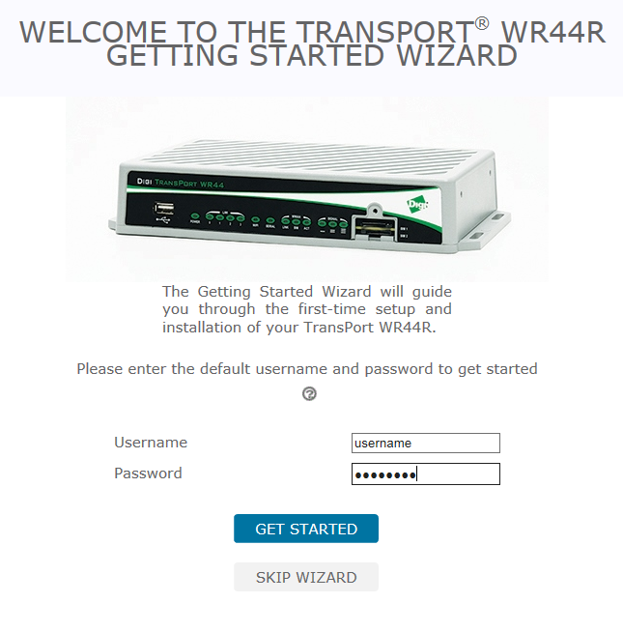

Log in with following credentials:
- Username: username
- Password: password

Configure Login credentials:

Username: root
Password: globalit
Access Level: Admin

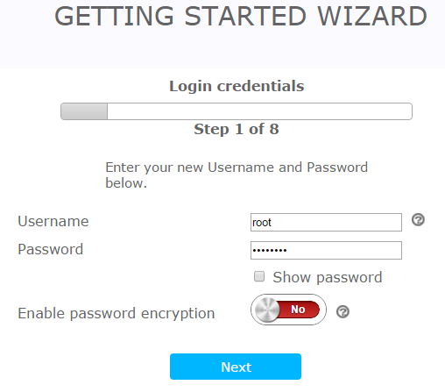

Cellular connectivity

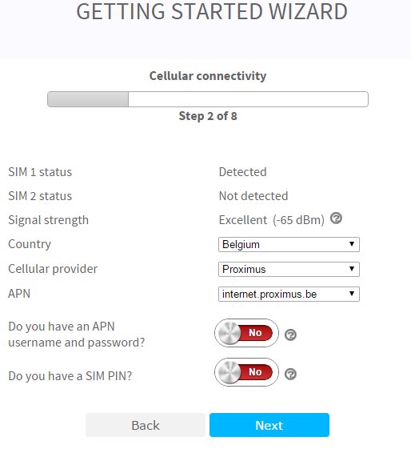
- Country:
- Cellular provider
- APN

Time configuration

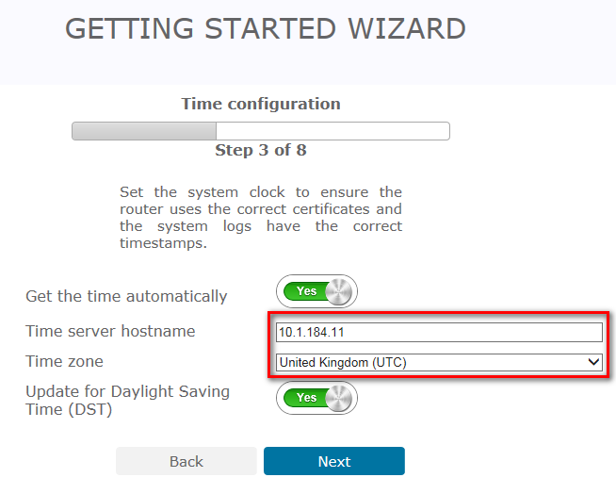

Time server: X.X.X.11 (Domain Controller new Standard)
Time zone: United Kingdom (UTC)

Remote Manager

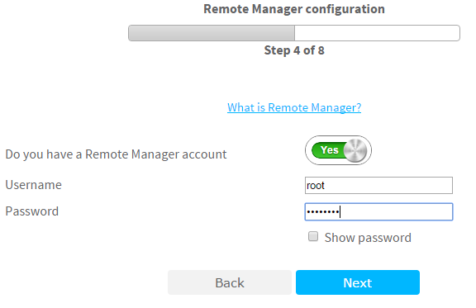

Username: root
Password: globalit

Interface Security

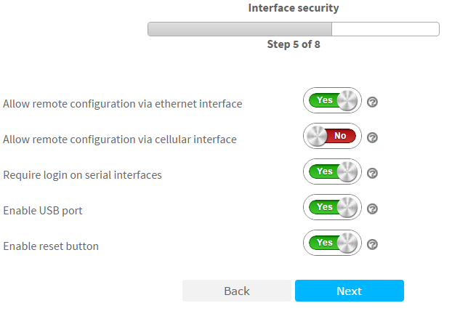

Leave default.

Services security

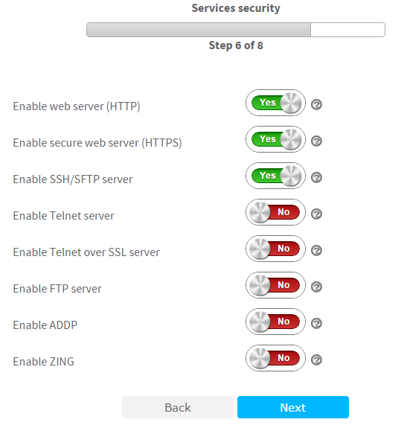

Leave default.

Wizard summary

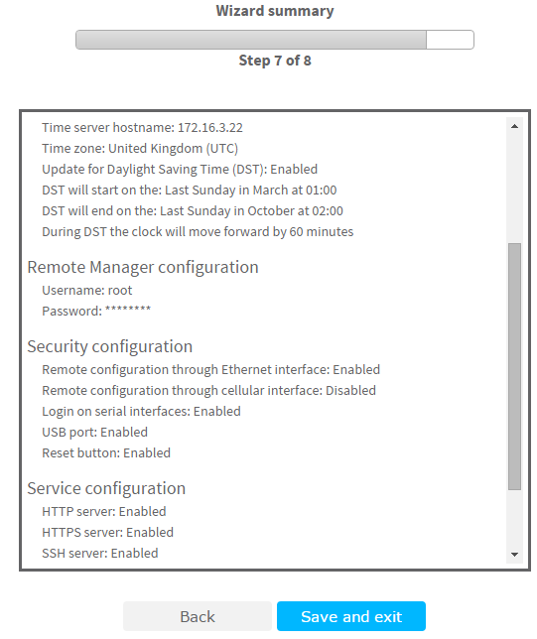

Click Save and exit.
If the Wizard ends with an error on the Device Cloud configuration, this can be ignored.

Configuration and management

Login With Root user

Users

Create User 2 under Configuration – Security > Users > User 0-9 > User 2 with the following credentials
- Username: threeg
- Password: JDN3G4V3ssels
- Access level: HIGH

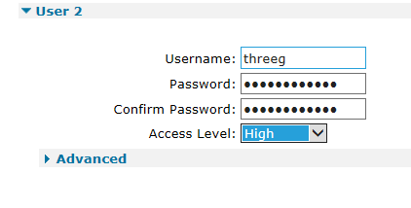

Hostname

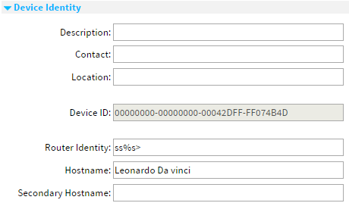
Configuration – System > Device Identity.

ETH 0

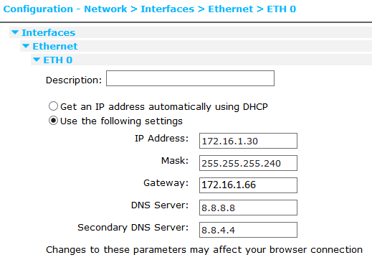
172.16.1.17

Reconfigure your local IP-address an reconnect on 172.16.1.30.

DHCP

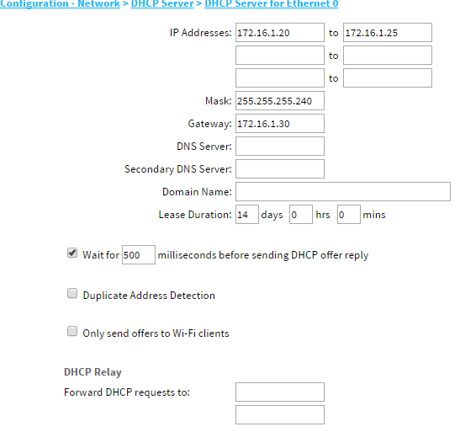

Mobile

Make sure that the SIM card is in Slot 1
Set APN settings
Enter SIM PIN (optional)

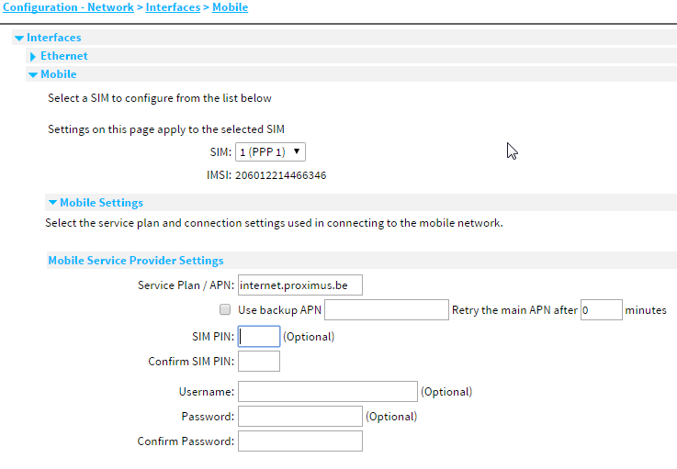

Save Configuration
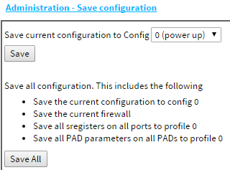

Auto reboot

Wizard >> SureLink wizard >> Active >> Default 50

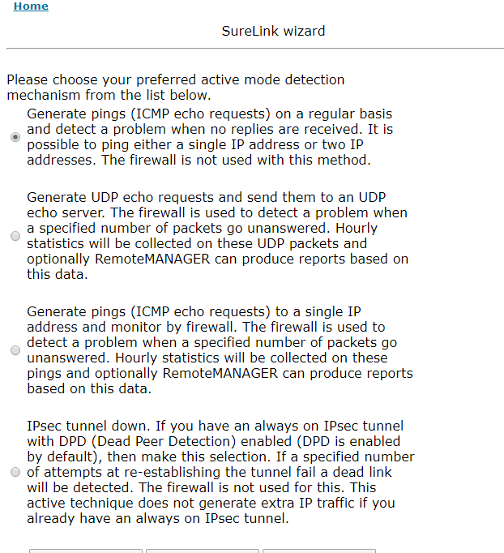
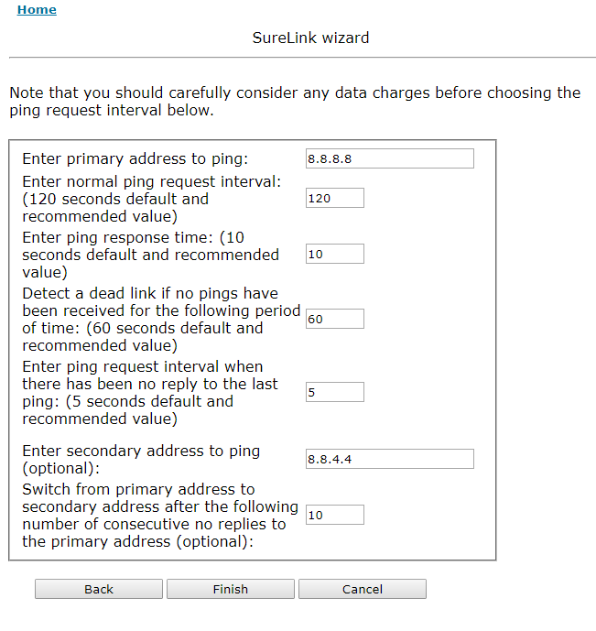

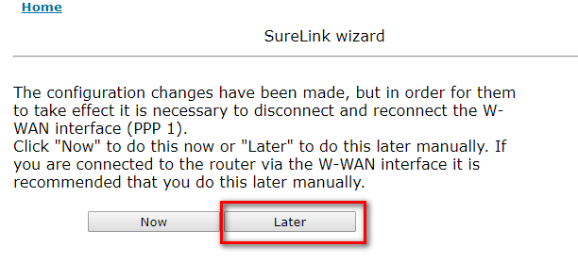

Change and recheck following settings:
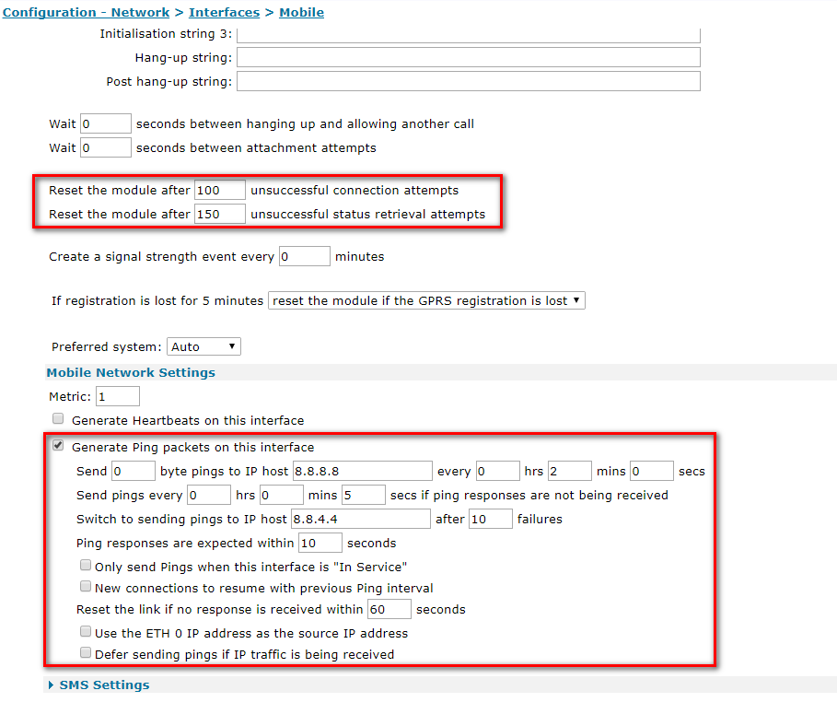

CREW 4G-MODEM

Settings:

Hostname: DN205 CREW 4G-MODEM

IP@: 172.16.1.65
Mask: 255.255.255.240
DG: 172.16.1.66
DNS1: 8.8.8.8
DNS2: 8.8.4.4

DHCP: 172.16.1.70 <> 172.16.1.75
MASK: 255.255.255.240
DG: 172.16.1.65

FFB simulation for Survey

IP@ 172.16.1.46
MASK 255.255.255.240
DG 172.16.1.33

DHCP
172.16.1.35 <> 172.16.1.40
MASK 255.255.255.0
DG 172.16.1.46

